

Darshan University

A Project Report on

**“Hotel Management System”**

Under the subject

**Software Engineering (2301CS405)**

B. Tech, Semester – IV

Computer Science & Engineering Department

|  |  |
| --- | --- |
| Submitted By | |
| Student Name: Jay Vegad | Enrollment No.:23010101294 |
| Academic Year  (2024-2025) | |
| Internal Guide  Prof. R. B. Gondaliya  Darshan University | Dean-DIET  Dr. Gopi Sanghani  Darshan University |

|  |  |
| --- | --- |
|  | **Computer Science & Engineering Department**  **Darshan University** |

**DECLARATION**

We hereby declare that the SRS, submitted along with the **Software Engineering** **(2301CS405)** for entitled **“Hotel Management System”** submitted in partial fulfilment for the Semester-5 of **Bachelor Technology (B. Tech)** in **Computer Science and Engineering (CSE)** Departmentto Darshan University, Rajkot, is a record of the work carried out at **Darshan University, Rajkot** under the supervision of R. B. Gondaliya and that no part of any of report has been directly copied from any students’ reports, without providing due reference.

(Jay Vegad)

Student’s Signature

Date: __________

|  |  |
| --- | --- |
|  | **Computer Science & Engineering Department**  **Darshan University** |

**CERTIFICATE**

This is to certify that the SRS on **“Hotel Management System” has** been satisfactorily prepared by **Jay Vegad** (**23010101294**) under my guidance in the fulfillment of the course **Software Engineering (2301CS405)** work during the academic year 2024-2025.

|  |  |  |
| --- | --- | --- |
| Internal Guide  Prof. R. B. Gondaliya  Darshan University |  | Dean-DIET  Dr. Gopi Sanghani  Darshan University |

**Acknowledgement**

I wish to express my sincere gratitude to my project guide Prof. R. B. Gondaliyaand all the faculty members for helping me through my project by giving me the necessary suggestions and advices along with their valuable co- ordination in completing this work.

I also thank my parents, friends and all the members of the family for their precious support and encouragement which they had provided in completion of my work. In addition to that, I would also like to mention the Darshan University personals who gave me the permission to use and experience the valuable resources required for the project from the University premises.

Thus, in conclusion to the above said, I once again thank the faculties and members of **Darshan University** for their valuable support in completion of the project.

Thanking You

**Jay Vegad**

**ABSTRACT**

The Hotel Management System (HMS) is a comprehensive software solution designed to streamline and enhance the operational efficiency of hotel management. This system integrates various functions including reservations, front desk operations, housekeeping, billing, and reporting into a unified platform. By automating routine tasks and providing real-time data access, HMS aims to improve the guest experience, optimize resource utilization, and increase overall operational productivity.

Key features of the system include an intuitive reservation interface for managing bookings, an automated check-in/check-out process, real-time room availability updates, and a centralized database for guest information. Additionally, the system supports financial management with integrated billing and invoicing capabilities, along with detailed reporting tools for performance analysis.

The HMS is designed with scalability in mind, accommodating both small boutique hotels and large multi-property chains. By leveraging modern technologies such as cloud computing and mobile access, the system offers flexibility and accessibility, enabling hotel staff to manage operations efficiently from various devices. Ultimately, the Hotel Management System aims to enhance customer satisfaction, streamline hotel operations, and provide valuable insights for strategic decision-making.

**Table of Contents**

List of Figures I

List of Tables II

1 Introduction 1

1.1 Product perspective 1

1.2 Product features 1

1.2.1 There are three different users who will be using this product: 1

1.2.2 The features that are required for the Librarian are: 1

1.2.3 The features that are required for the Member are: 1

1.3 Functional Requirement 1

1.3.1 Librarian 1

1.3.2 Member 2

1.4 Non-Functional Requirement 2

1.4.1 Usability: 2

1.4.2 Accuracy: 2

1.4.3 Availability: 2

1.4.4 Maintainability: 2

2 Design and Implementation Constraints 3

2.1 Use case diagram 3

2.2 Activity diagram and Swimlane diagram 4

2.3 Sequence diagram 5

2.4 State diagram 6

2.5 Class diagram 7

2.6 Data flow diagram 8

2.6.1 Context diagram (level-0) 8

2.6.2 DFD Level-1 8

2.6.3 DFD Level-2 9

3 External interface requirement (Screens) 10

3.1 Screen-1: Registration Form 10

3.2 Screen-2: Login Form 11

3.3 Screen-3: Add borrower book 12

4 Database design 13

4.1 List of Tables 13

5 Stories and Scenario 14

5.1 Story-1: Add New Book in Library Catalogue 14

5.1.1 Scenario# S1.1 14

5.1.2 Scenario# S1.2 14

5.1.3 Scenario# S1.3 14

5.2 Story-2: Search Book 15

5.3 Story-3: Manage due date for borrowed book 15

5.4 Story-4: Renew book 15

5.5 Story-5: Generate a report on book usage and availability 15

6 Test cases 16

7 References 20

# List of Figures

Figure 2.1‑1 Use case diagram for library management system 3

Figure 2.2‑1 Activity diagram for Book Issue 4

Figure 2.2‑2 Swimlane diagram for Book Issue 4

Figure 2.3‑1 Sequence diagram for Book Issue 5

Figure 2.4‑1 State diagram of Book 6

Figure 2.4‑2 State diagram for Librarian 6

Figure 2.5‑1 Class diagram for Library management system 7

Figure 2.6‑1 Context diagram for Library management system 8

Figure 2.6‑2 DFD level-1 for Library management system 8

Figure 2.6‑3 DFD level-2 for Issue book 9

Figure 3.1‑1 Screen-1: Registration Form 10

Figure 3.2‑1 Screen-2: Login Form 11

Figure 3.3‑1 Screen-3: Add borrower book 12

# List of Tables

Table 3.1‑1 Screen element of Registration form 10

Table 3.2‑1 Screen element of Login form 11

Table 3.3‑1 Screen element of Add borrower book 12

Table 4.1‑1 Table: Book 13

Table 4.1‑2 Table: Borrower 13

Table 4.1‑3 Table: Staff 13

Table 4.1‑4 Table: Student 13

# Introduction

## Product perspective

The Hotel Management System (HMS) transforms traditional hotel management practices into a modern, internet-based application, facilitating streamlined operations and enhanced guest interactions. The system supports multiple user roles, including Admin, Manager, Receptionist, and Guest, each with tailored functionalities to ensure efficient management and superior guest experiences. By integrating key operational components such as reservations, front desk operations, housekeeping, billing, and reporting into a unified platform, the HMS is designed to meet the needs of various types of hotels, from small boutique establishments to large hotel chains.

## Product features

### There are four different users who will be using this product:

* Admin who will manage system settings and user accounts.
* Manager who will oversee hotel operations and staff.

• Receptionist who will handle guest interactions and front desk operations.

* Guest who will rooms and manage their stay.

### The features that are required for the Admin are:

* Set up and configure system parameters, including room types, rates, and hotel policies.
* Create, modify, and deactivate user accounts for Managers, Receptionists, and other staff.
* Manage user permissions and access levels.
* Perform regular backups to ensure data integrity and security.
* Oversee system performance and handle technical issues. Print the spine labels for the book.
* Generate and review system-wide reports, including user activity, system performance, and financial summaries.

### The features that are required for the Manager are:

* Oversee and manage all room reservations, including modifications and cancellations

• Create and manage guest invoices, process payments, and oversee financial transactions.

• Update and manage room information, including availability, rates, and types.

* Assign tasks and monitor the performance of Receptionists and other staff.

• Review and manage guest profiles and preferences.

### The features that are required for the Receptionist are:

• Efficiently process guest check-ins and check-outs, including room assignment and payment handling.

• Search for and manage guest reservations, handle special requests, and make modifications as needed.

• Assign and update room assignments based on guest preferences and availability.

• Address guest inquiries, manage requests for additional services, and provide information about hotel amenities.

• Generate invoices for guests, process payments, and handle billing queries.

### The features that are required for the Guest are:

* Search for available rooms, make reservations, and select room preferences online.
* Access and manage personal booking details, view past and upcoming stays, and update personal information.
* Submit requests for special services or room preferences, such as additional amenities.
* Provide feedback or reviews on their stay and hotel services.

## Functional Requirement

### Admin

* Login and Authentication: Users can log in with a username and password, reset forgotten passwords, and ensure secure access to the system.

### • Room Availability Check: Users can view room availability for specific dates and filter available rooms by type for easier selection.

### • Basic Reservation: Users can create new reservations and view existing ones, facilitating the booking process for guests.

### • Guest Information Management: Users can add, update, and search for guest information by name or booking reference, maintaining accurate guest records.

### • Basic Check-in/Check-out: Users can check guests in and out, updating room status to occupied or vacant accordingly.

### • Invoice Generation: Users can generate simple invoices for a guest’s stay, and print or email them directly to the guest.

### • Housekeeping Status Update: Users can update the cleaning status of rooms and assign cleaning tasks to housekeeping staff.

### • Guest Feedback Collection: Users can record guest feedback and comments, and view a list of all feedback received.

### • Basic Report Generation: Users can generate basic reports on occupancy rates and view revenue summaries for specific periods.

### • Profile Management: Users can update their profile information and change their passwords, maintaining up-to-date personal details.

### Guest

• Online Booking:

* Guests can search for available rooms by specifying dates and preferences.
* Guests can view room details, amenities, and rates before making a reservation.
* Guests can complete the booking process online and receive a confirmation email.

• Booking Management:

* Guests can view their current and past bookings.
* Guests can modify or cancel their reservations based on hotel policies.
* Guests receive notifications for any changes or cancellations to their bookings.

• Profile Management:

* Guests can create their personal profiles, including contact information.
* Guests can update their preferences and special requests for future stays.
* Guests can change their account passwords and handle security settings.

• Payment Processing:

* Guests can make online payments using various payment methods (credit card, debit card, digital wallets).
* Guests can view their payment history and download invoices.
* The system provides secure payment processing to protect guest financial information.

• Feedback and Reviews:

* Guests can submit feedback and reviews about their stay and hotel services.
* Guests can rate their experience and provide suggestions for improvement.
* Guests receive acknowledgment and responses to their feedback.

• Check-in and Check-out:

* Guests can use online check-in to expedite the arrival process.
* Guests can request late check-out or early check-in based on availability.
* The system provides guests with a digital key or information about room access.

• Service Requests:

* Guests can request additional services such as room service, housekeeping, or maintenance.
* Guests can track the status of their service requests in real-time.
* Guests receive notifications when their requests are fulfilled.

• Loyalty Program Management:

* Guests can enroll in and handle their membership in the hotel’s loyalty program.
* Guests can view and redeem loyalty points for discounts or special offers.
* Guests receive updates on their loyalty status and exclusive member benefits.

• Special Offers and Promotions:

* Guests can view and book special offers or promotional packages.
* Guests receive notifications about exclusive deals and discounts.
* The system allows guests to apply promo codes during the booking process.

• Communication and Support:

* Guests can chat with customer support for assistance with their reservations.
* Guests can access a FAQ section for common queries and information.
* Guests receive timely responses to their inquiries and support requests.

• Mobile Accessibility:

* Guests can access the hotel management system through a mobile app or mobile friendly website.
* Guests can use mobile check-in and digital keys for a seamless experience.
* The mobile platform provides all essential features for managing bookings and services.

### Manager

• User and Role Management:

* Managers can create, update, and delete user accounts for staff.
* Managers can assign roles and permissions to ensure appropriate access levels.
* Managers can deactivate or reactivate user accounts as needed.

• Room and Rate Management:

* Managers can add, update, or remove room details, including type, rate, and availability.
* Managers can set seasonal or promotional rates and handle special offers.
* Managers can oversee room inventory and ensure accurate status updates.

• Reservation Management:

* Managers can view, modify, or cancel guest reservations.
* Managers can access detailed booking reports and analyze reservation trends.
* Managers can create overbooking scenarios and reallocate rooms if necessary.

• Check-in/Check-out Oversight:

* Managers can monitor the check-in and check-out process to ensure efficiency.
* Managers can resolve issues related to guest arrivals and departures.
* Managers can update room statuses and ensure timely housekeeping.

• Billing and Financial Management:

* Managers can generate detailed invoices and process guest payments.
* Managers can review financial reports, including revenue, expenses, and occupancy rates.
* Managers have the ability to handle discounts, process refunds, and make adjustments to guest bills.

• Staff Scheduling and Management:

* Managers can create and handle staff schedules, including shift assignments.
* Managers can track staff attendance and handle shift changes or absences.
* Managers can evaluate staff performance and provide feedback.

• Maintenance Management:

* Managers can log and track maintenance requests and issues.
* Managers can assign maintenance tasks to staff and monitor completion.
* Managers can review maintenance logs and ensure timely resolution of problems.

• Customer Feedback and Complaint Resolution:

* Managers can review and respond to guest feedback and complaints.
* Managers can implement actions to address issues and improve guest satisfaction.
* Managers can track the status of complaints and ensure follow-up.

• Report Generation and Analysis:

* Managers can generate comprehensive reports on various aspects of hotel operations.
* Managers can analyze data to identify trends, strengths, and areas for improvement.
* Managers can export reports for presentations or further analysis.

• Marketing and Promotions Management:

* Managers can create and handle marketing campaigns and promotional offers.
* Managers can track the effectiveness of marketing efforts and adjust strategies.
* Managers can collaborate with marketing teams to enhance hotel visibility.

### Receptionist

• User and Role Management:

* Managers can create, update, and delete user accounts for staff.
* Managers can assign roles and permissions to ensure appropriate access levels.
* Managers can deactivate or reactivate user accounts as needed.

• Room and Rate Management:

* Managers can add, update, or remove room details, including type, rate, and availability.
* Managers can set seasonal or promotional rates and handle special offers.
* Managers can oversee room inventory and ensure accurate status updates.

• Reservation Management:

* Managers can view, modify, or cancel guest reservations.
* Managers can access detailed booking reports and analyze reservation trends.
* Managers can handle overbooking scenarios and reallocate rooms if necessary.

• Check-in/Check-out Oversight:

* Managers can monitor the check-in and check-out process to ensure efficiency.
* Managers can resolve issues related to guest arrivals and departures.
* Managers can update room statuses and ensure timely housekeeping.

• Billing and Financial Management:

* Managers can generate detailed invoices and process guest payments.
* Managers can review financial reports, including revenue, expenses, and occupancy rates.
* Managers can handle discounts, refunds, and adjustments to guest bills.

• Staff Scheduling and Management:

* Managers can create and handle staff schedules, including shift assignments.
* Managers can track staff attendance and handle shift changes or absences.
* Managers can evaluate staff performance and provide feedback.

• Maintenance Management:

* Managers can log and track maintenance requests and issues.
* Managers can assign maintenance tasks to staff and monitor completion.
* Managers can review maintenance logs and ensure timely resolution of problems.

• Customer Feedback and Complaint Resolution:

* Managers can review and respond to guest feedback and complaints.
* Managers can implement actions to address issues and improve guest satisfaction.
* Managers can track the status of complaints and ensure follow-up. •

Report Generation and Analysis:

* Managers can generate comprehensive reports on various aspects of hotel operations.
* Managers can analyze data to identify trends, strengths, and areas for improvement.
* Managers can export reports for presentations or further analysis.

• Marketing and Promotions Management:

* Managers can create and handle marketing campaigns and promotional offers.
* Managers can track the effectiveness of marketing efforts and adjust strategies.
* Managers can collaborate with marketing teams to enhance hotel visibility.

## Non-Functional Requirement

### Usability:

* The UI should be simple enough for everyone to understand and get the relevant information without any special training. Different languages can be provided based on the requirements.

### Accuracy:

* The data stored about the books and the fines calculated should be correct, consistent, and reliable.

### Availability:

* The System should be available for the duration when the library operates and must be recovered within an hour or less if it fails. The system should respond to the requests within two seconds or less.

### Maintainability:

* The software should be easily maintainable and adding new features and making changes to the software must be as simple as possible. In addition to this, the software must also be portable.

# Design and Implementation Constraints

## Use case diagram

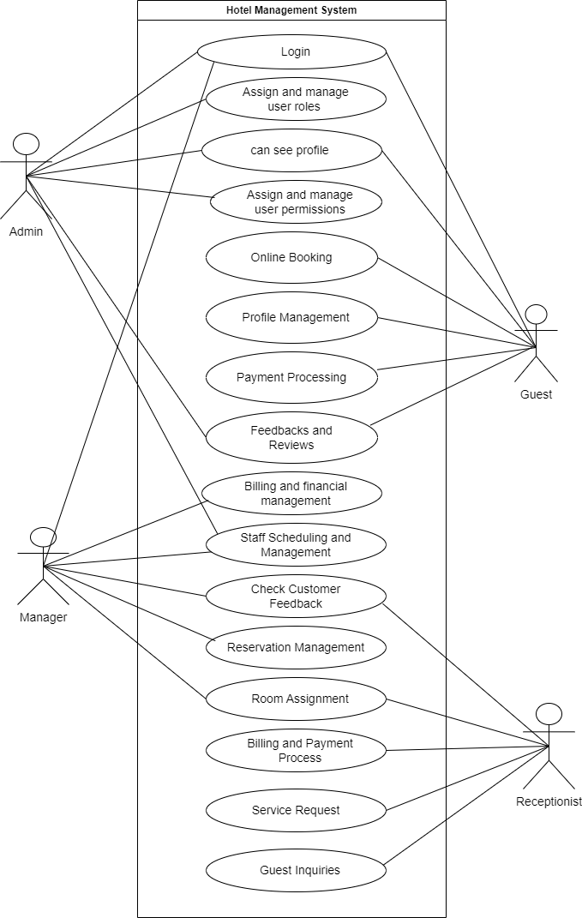

Figure 2.1‑1 Use case diagram for hotel management system

## Activity diagram and Swimlane diagram

### Activity diagram 1

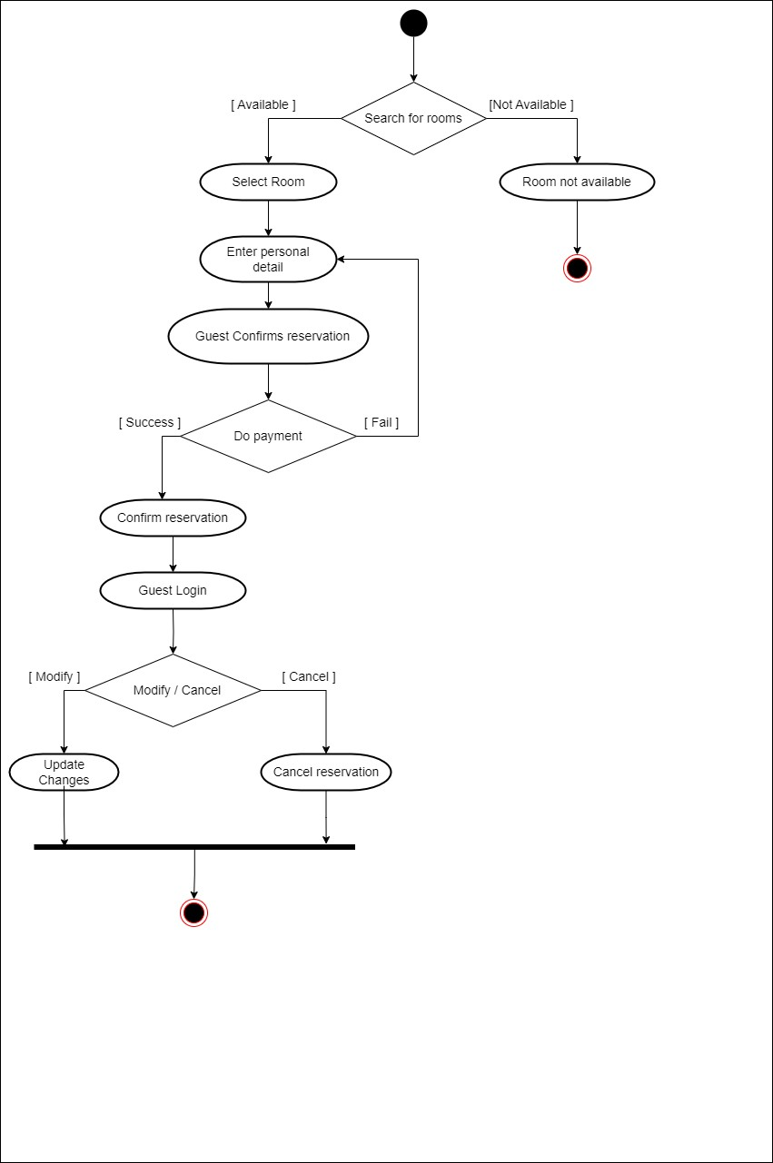

Figure 2.2‑1 Activity diagram for Reserve a room

### Activity diagram 2

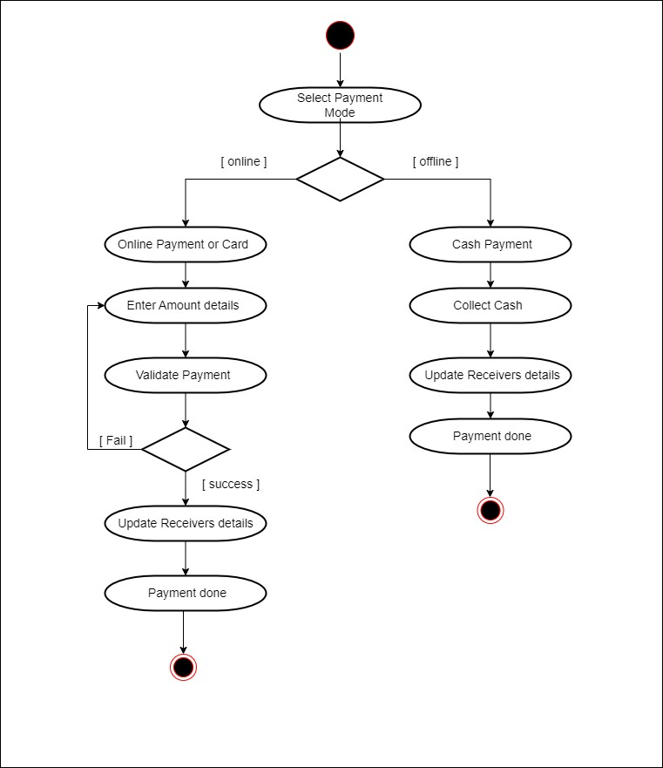

Figure 2.2‑2 Activity diagram for Payment

### Swimlane diagram 1

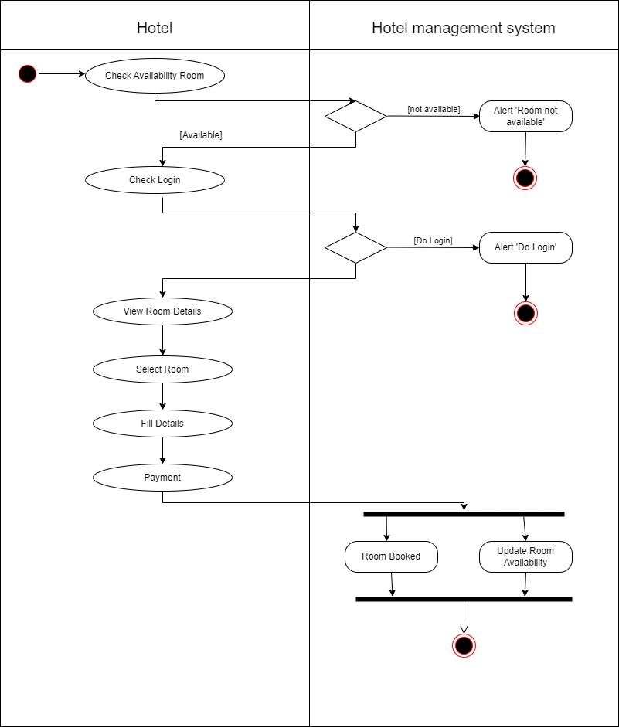

*Figure 2.2-2 Swimlane diagram for Room booking*

### Swimlane diagram 2

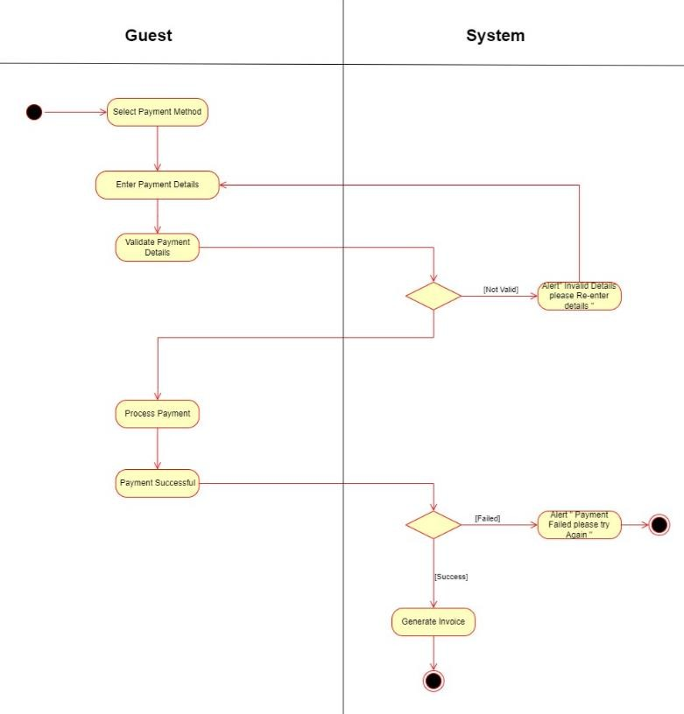

*Figure 2.2-3 Swimlane diagram for Payment*

## Sequence diagram

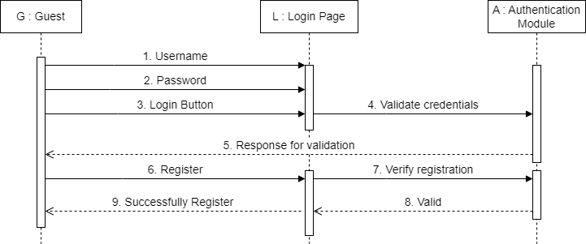

Figure 2.3‑1 Sequence diagram for Login request

## State diagram

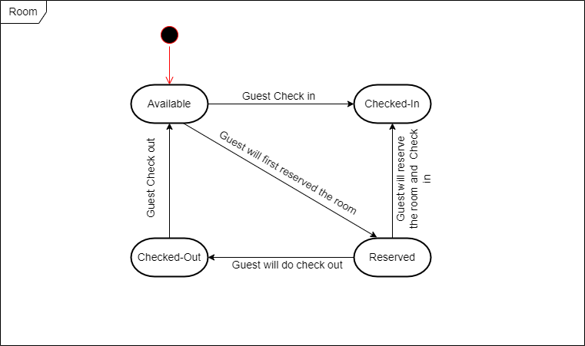

Figure 2.4‑1 State diagram of Room

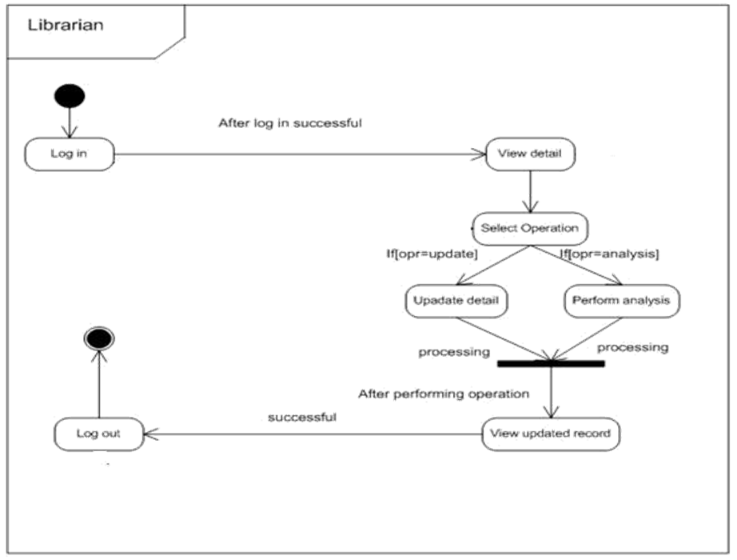

Figure 2.4‑2 State diagram for Librarian

## Class diagram

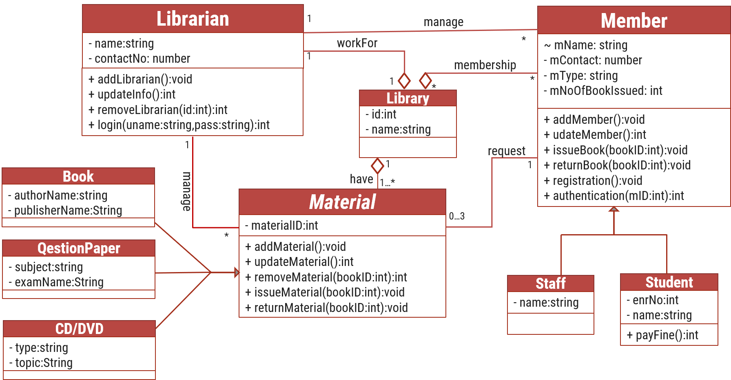

Figure 2.5‑1 Class diagram for Library management system

## Data flow diagram

### Context diagram (level-0)

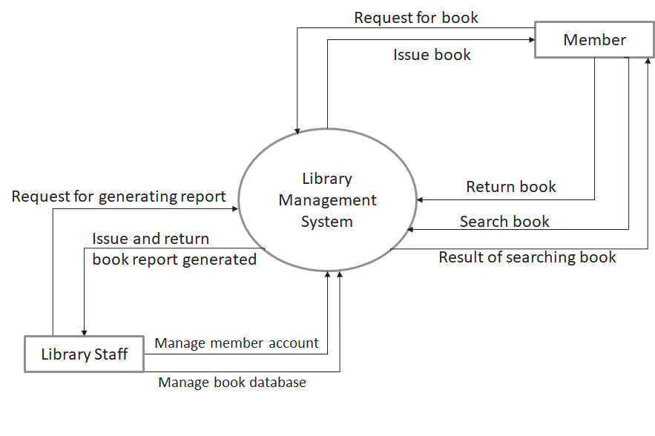

Figure 2.6‑1 Context diagram for Library management system

### DFD Level-1

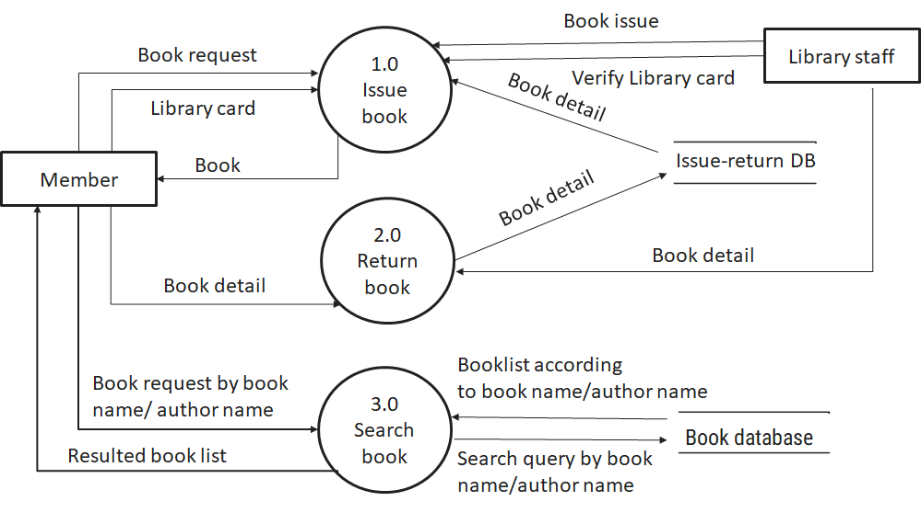

Figure 2.6‑2 DFD level-1 for Library management system

### DFD Level-2

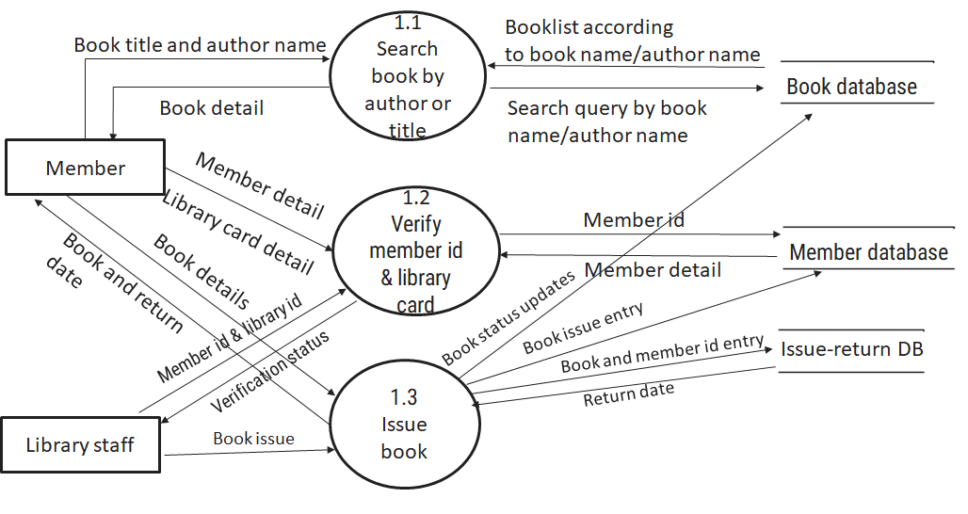

Figure 2.6‑3 DFD level-2 for Issue book

# External interface requirement (Screens)

## Screen-1: Registration Form

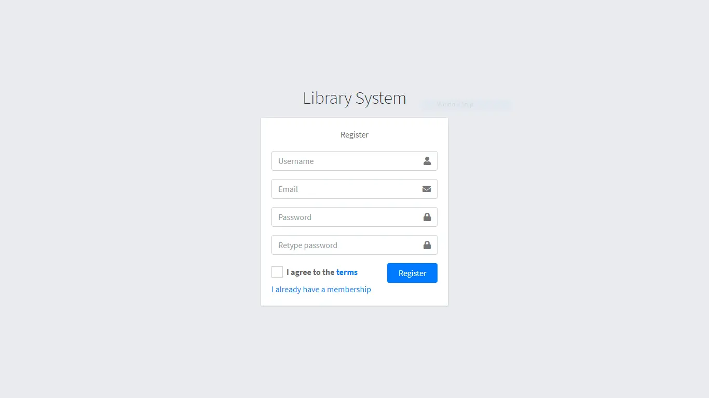

Figure 3.1‑1 Screen-1: Registration Form

**Purpose:** This form will allow the target end-users to register in the system. To register , the following information will be encoded in the system.

Table 3.1‑1 Screen element of Registration form

|  |  |  |  |  |  |
| --- | --- | --- | --- | --- | --- |
| Sr. | Screen Element | Input Type | O/M | 1/N | Description |
| 1 | Username | Textbox | M | 1 | Username field should be editable and accept the Username. |
| 2 | Email | Textbox | M | 1 | Email field should be editable and accept the email with proper format. |
| 3 | Password | Password | M | 1 | Password field should be editable and accept the password and display as star or dot. |
| 4 | Retype password | Password | M | 1 | Retype Password field should be editable and accept the password and display as star or dot. |
| 5 | I agree to the terms | Checkbox | M | 1 | Checkbox for accepting terms and condition. |
| 6 | I already have a membership | Link | ------ | ------ | Link for navigate to login page for registered user. |
| 7 | Register | Button | ------ | ------ | Register is a button for store the entered data into database. |

## Screen-2: Login Form

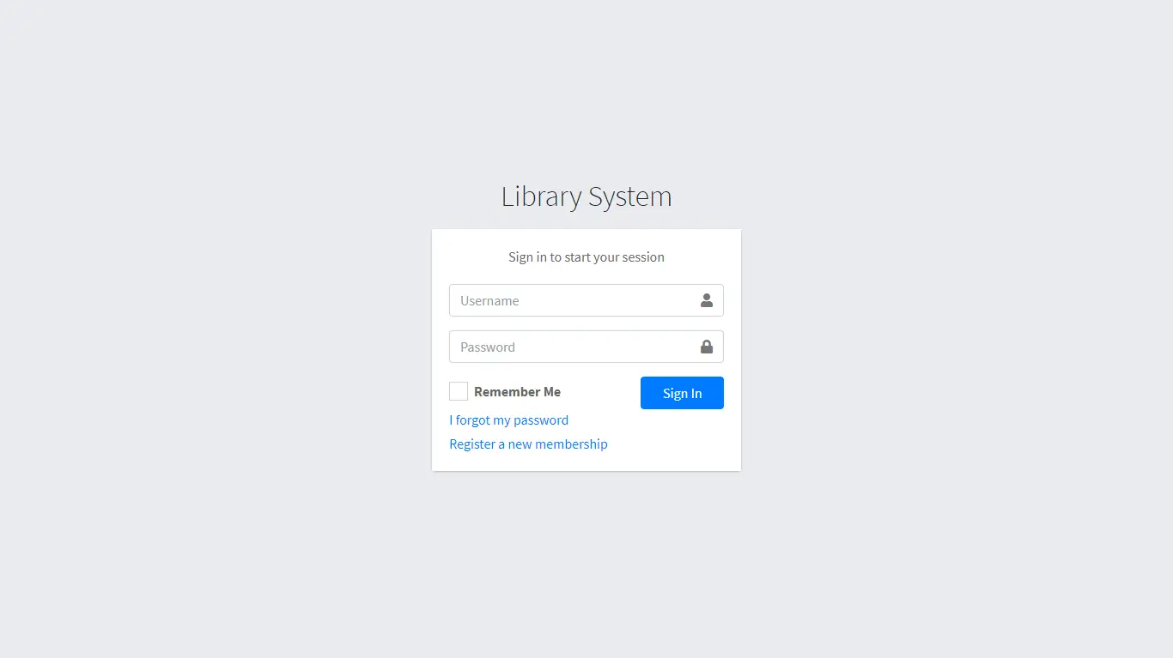

Figure 3.2‑1 Screen-2: Login Form

**Purpose:** This form will be used by the system’s users to access records and features of the system. The users will input the correct combination of their username and password to be able to login to the system.

Table 3.2‑1 Screen element of Login form

|  |  |  |  |  |  |
| --- | --- | --- | --- | --- | --- |
| Sr. | Screen Element | Input Type | O/M | 1/N | Description |
| 1 | Username | Textbox | M | 1 | Username field should be editable and accept the Username. |
| 2 | Password | Password | M | 1 | Password field should be editable and accept the password and display as star or dot. |
| 3 | Remember Me | Checkbox | M | 1 | Saving login credentials through remember me checkbox |
| 4 | I forgot my password | Link | ------ | ------ | Link for navigate to Forgot password page for allows users to recover password. |
| 5 | Register a new membership | Link | ------ | ------ | Link for navigate to membership registration. |
| 6 | Sign in | Button | ------ | ------ | Login button navigates to another page even if valid login credentials. |

## Screen-3: Add borrower book

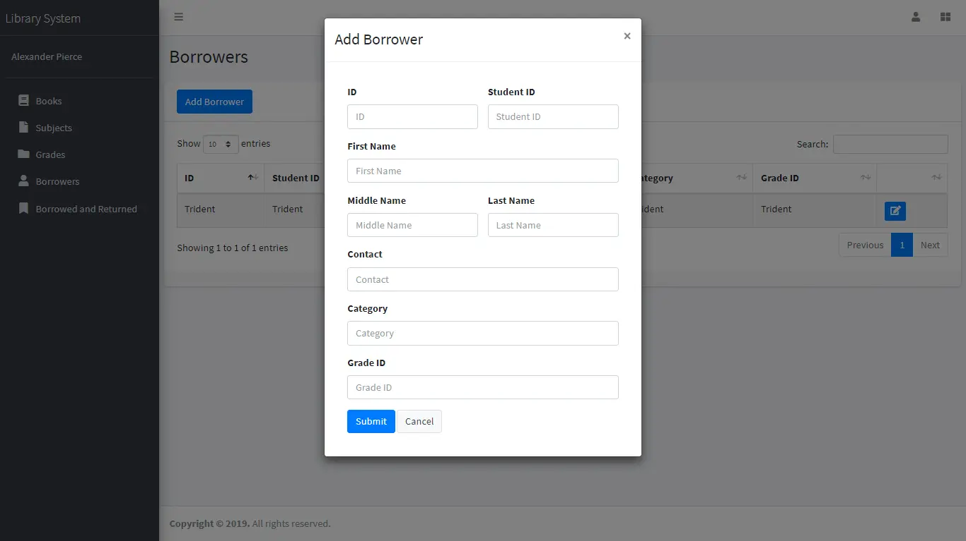

Figure 3.3‑1 Screen-3: Add borrower book

**Purpose:** This module will allow the system administrator to add, edit, update or delete borrowers of book. The admin can add borrower information and manage it.

Table 3.3‑1 Screen element of Add borrower book

|  |  |  |  |  |  |
| --- | --- | --- | --- | --- | --- |
| Sr. | Screen Element | Input Type | O/M | 1/N | Description |
| 1 | Borrower ID | Textbox | M | 1 | Borrower ID field should be editable and fill autogenerated Borrower ID. |
| 2 | Student ID | Textbox | M | 1 | Student ID field should be editable and accept Student barcode id. |
| 3 | First Name | Textbox | M | 1 | First Name field should be editable and accept only string as a borrower first name. |
| 4 | Middle Name | Textbox | O | 1 | Middle Name field should be editable and accept only string as a borrower middle name. |
| 5 | Last Name | Textbox | M | 1 | Last Name field should be editable and accept only string as a borrower last name. |
| 6 | Contact | Textbox | M | 1 | Contact field should be editable and accept only 10-digit mobile number. |
| 7 | Grade Id | Textbox | O | 1 | Auto fetch detail from the database if proper student id is entered. |
| 8 | Submit | Button | ----- | ----- | Submit is a button for store the entered data into database. |
| 9 | Cancel | Button | ----- | ----- | Cancel is a button for close add borrower dialog. |

# Database design

## List of Tables

* Book
* Borrower
* Student
* Staff

Table 4.1‑1 Table: Book

|  |  |  |  |  |
| --- | --- | --- | --- | --- |
| Column | Data Type | Null | Keys & Constrains | Default Value & Description |
| BookID | int | NN | PK (Auto Increment) |  |
| BookName | varchar(100) | NN |  |  |
| ISBN | varchar(100) | AN |  |  |
| Publication_year | int | AN |  |  |
| Language | varchar(50) | AN |  |  |

Table 4.1‑2 Table: Borrower

|  |  |  |  |  |
| --- | --- | --- | --- | --- |
| Column | Data Type | Null | Keys & Constrains | Default Value & Description |
| BorrowerID | int | NN | PK (Auto Increment) |  |
| BookID | varchar(100) | NN | FK | Reference of Book Table |
| BorrowedFromDate | DateTime | AN |  |  |
| BorrowedToDate | DateTime | AN |  |  |
| ActualReturnDate | DateTime | AN |  |  |
| IssuedBy | int | NN | FK | Reference of Student and Staff Table |

Table 4.1‑3 Table: Staff

|  |  |  |  |  |
| --- | --- | --- | --- | --- |
| Column | Data Type | Null | Keys & Constrains | Default Value & Description |
| StaffID | int | NN | PK (Auto Increment) |  |
| StaffName | varchar(100) | AN |  |  |
| IsAdmin | Boolean | AN |  |  |
| Designation | varchar(100) | AN |  |  |

Table 4.1‑4 Table: Student

|  |  |  |  |  |
| --- | --- | --- | --- | --- |
| Column | Data Type | Null | Keys & Constrains | Default Value & Description |
| StudentID | int | NN | PK (Auto Increment) |  |
| StudentName | varchar(100) | AN |  |  |
| Gender | varchar(100) | AN |  |  |
| DOB | DateTime | AN |  |  |
| Department | varchar(100) | AN |  |  |
| Contact | number(10,0) | AN |  |  |

# Stories and Scenario

## Story-1: Add New Book in Library Catalogue

|  |  |  |
| --- | --- | --- |
| *Story # S1* | : | As a Librarian,  I want to add a new book in library catalogue  So that everyone can easily find and borrow it. |
| Priority | **:** | High |
| Estimate | **:** | XL |
| Reason | **:** | The addition of a new book to the library catalogue is crucial for ensuring that the library's collection is up-to-date and accessible to everyone. |

### Scenario# S1.1

|  |  |  |
| --- | --- | --- |
| *Scenario# S1.1* | : | Adding a New Book with Valid Information |
| Prerequisite | **:** | Librarian is logged in to the Library management system. |
| Acceptance Criteria | **:** | **Given:**  The Librarian is navigated to the library catalog management page. Valid book information, including title, author, ISBN, and other relevant details is added.  **When:**  The librarian selects the "Add New Book" option  And The librarian enters valid book details  The librarian clicks the "Save" button to add the book to the catalog.  **Then t**he system successfully adds the book to the catalog and the librarian receives a confirmation message with the book's identification number. |

### Scenario# S1.2

|  |  |  |
| --- | --- | --- |
| *Scenario# S1.2* | : | Adding a New Book with Invalid Information. |
| Prerequisite | **:** | The librarian is logged into the library management system. |
| Acceptance Criteria | **:** | **Given:** The librarian is on the library catalogue management page  **When:** The librarian selects the "Add New Book" option and the librarian enters an incomplete or incorrect book details and librarian clicks the "Save" button to add the book to the catalogue.  **Then t**he system displays error messages for the incorrect or missing information and the book is not added to the catalogue. |

### Scenario# S1.3

|  |  |  |
| --- | --- | --- |
| *Scenario# S1.3* | : | Attempting to Add a Duplicate Book |
| Prerequisite | **:** | The librarian is logged into the library management system and the librarian is on the library catalogue management page |
| Acceptance Criteria | **:** | **Given**: The book information, including title, author, ISBN, and other relevant details, is available and the book with the same ISBN is already in the catalogue.  **When**: User Clicks on “Add book” button. Enter a number of copies with the same book detail mentioned in the field.  **Then**: Generate unique book id, barcode and spine label for various book of same title. |

## Story-2: Search Book

|  |  |  |
| --- | --- | --- |
| *Story # S2* | : | As a Librarian or member,  I want to search for books by title, author, or keyword,  So that I can quickly find books that match my interests. |
| Priority | **:** | High |
| Estimate | **:** | M |
| Reason | **:** | Implementing a search functionality is essential for enhancing the user experience, as it allows librarian and member to efficiently discover and access the library's resources. |

## Story-3: Manage due date for borrowed book

|  |  |  |
| --- | --- | --- |
| *Story # S3* | : | As Librarian,  I want to manage due dates for borrowed books  So that I can ensure that books are returned on time and avoid overdue fines. |
| Priority | **:** | High |
| Estimate | **:** | M |
| Reason | **:** | Proper due date management is crucial for maintaining the library's collection and ensuring that books are available for all members. |

## Story-4: Renew book

|  |  |  |
| --- | --- | --- |
| *Story # S3* | : | As Librarian,  I want to renew a book that I have borrowed  So that I can extend my borrowing period if needed. |
| Priority | **:** | Medium |
| Estimate | **:** | M |
| Reason | **:** | Book renewal functionality is a convenience feature for librarian, allowing them to keep a book for an extended period if no one else has requested it. |

## Story-5: Generate a report on book usage and availability

|  |  |  |
| --- | --- | --- |
| *Story # S3* | : | As Librarian,  I want to generate reports on library usage and book availability  So that I can make informed decisions about library’s books. |
| Priority | **:** | Medium |
| Estimate | **:** | L |
| Reason | **:** | Reporting functionality helps librarians track the usage of library resources and make data-driven decisions to improve services and collections. |

# Test cases

|  |  |  |  |
| --- | --- | --- | --- |
| Project Name: | EMI Calculator | Test Designed by: | P. U. Jadeja |
| Module Name: | **Login** | **Test Designed date:** | 01-10-2023 |
| Release Version: | **1.0** | **Test Executed by:** | **R. B. Gondaliya** |
|  |  | **Test Execution date:** | 15-01-2023 |

|  |  |  |  |  |
| --- | --- | --- | --- | --- |
| Pre-condition: Web application should be accessible | | | | |
| Test Case ID | **Test Title** | **Test Type** | **Description** | **Test Case ID** |
| TC_001 | Login to web application with valid credential | Functional | Login to Library management system web application through valid credential | TC_001 |
| TC_002 | Login to web application with invalid credential | Functional | Login to Library management system web application through invalid credential | TC_002 |
| TC_003 | Varify login page elements | GUI | varify that all elements are availabe on login page | TC_003 |

|  |  |
| --- | --- |
| **Test Case Title** | Login to web application with valid credential |
| **Test Type** | Functional |
| **Test Priority** | High |
| **Pre-condition** | Web application should be accessible |

|  |  |  |  |  |  |  |  |
| --- | --- | --- | --- | --- | --- | --- | --- |
| **Test Step** | **Test Case Description** | **Expected Result** | **Actual Result** | **Status** | **Comment** | **Data** | **BUG ID** |
| 1 | Access Web application URL | The site launched properly | Site launched successfully | Pass |  | <https://accounts.google.com/ServiceLogin> |  |
| 2 | Enter valid Username in username field | Username field should be editable and accept the Username | Username input accepted | Pass |  | Username:  Rbgondaliya@gmail.com |  |
| 3 | Enter valid Password in Password field | Password field should be editable and accept the password and display as star or dot | Password input displayed in dot and accepted | pass |  | Password: rbgondaliya |  |
| 4 | Enter valid captcha code in captch field | Captch field should editable and accept captcha and captcha is case sensitive | Captcha input accepted | Pass | Step required when human action validation perform | get captcha from image which is near by captcha field |  |
| 5 | Click on login button | User should login into site and navigated to dashboard | User navigated to dashboard and username should br display in top of the right side. | pass |  |  |  |

|  |  |
| --- | --- |
| **Test Case Title** | Login to web application with invalid credential |
| **Test Type** | Functional |
| **Test Priority** | Medium |
| **Pre-condition** | Web application should be accessible |

|  |  |  |  |  |  |  |  |
| --- | --- | --- | --- | --- | --- | --- | --- |
| **Test Step** | **Test Case Description** | **Expected Result** | **Actual Result** | **Status** | **Comment** | **Data** | **Bug ID** |
| 1 | Verify that User is not able to Login with invalid Username and invalid Password | Should be display an error message enter wrong username or password | Display an error of wrong username and password | Pass |  |  |  |
| 2 | Verify that User is not able to Login with Valid Username and invalid Password | Should be display an error message enter wrong password | Display an error of wrong password | Pass |  |  |  |
| 3 | Verify that User is not able to Login with invalid Username and Valid Password | Should be display an error message User not found | Display an error Username not found | Pass |  |  |  |
| 4 | Verify that User is not able to Login with blank Username or Password | Set required field validation message for Username and Password | Display an error of wrong username and password | Fail | Not performa a validation function fix it |  | Bug_002 |

|  |  |
| --- | --- |
| **Test Case Title** | Varify login page elements |
| **Test Type** | GUI |
| **Test Priority** | Medium |
| **Pre-condition** | Web application should be accessible |

|  |  |  |  |  |  |  |  |
| --- | --- | --- | --- | --- | --- | --- | --- |
| **Test Step** | **Test Case Description** | **Expected Result** | **Actual Result** | **Status** | **Comment** | **Data** | **Bug ID** |
| 1 | Launch application with the given url | The site launched properly | Site launched successfully | Pass |  | <https://accounts.google.com/ServiceLogin> |  |
| 2 | Verify that the login screen contains elements such as Username, Password, Sign in button, Remember password check box, Forgot password link, and Create an account link. | All listed control displayed properly on the page | Login page loaded successfully | Pass |  |  |  |
| 3 | Verify that cursor is focused on “Username” text box on the page load | Cursor is focused in Username textbox | Cursor focus in Username textbox | Pass |  |  |  |
| 4 | Verify that tab functionality is working properly or not | When tab pressed cursor move in next control | Cursor moving in next control | Pass |  |  |  |
| 5 | Verify that all the fields such as Username, Password has a valid placeholder | All text fields have proper placeholder | All text fields have proper placeholder | Pass |  |  |  |
| 6 | Verify that the labels float upward when the text field is in focus or filled (In case of floating label) | When field is focused or filled, label display on top of the filled | When field is focus or filled, label display on top of the filled | Pass | step required when fields with floating label |  |  |
| 7 | verify that forgot password link working properly | when click on forgot password load forgot passworg page | forgot password link not working | Fail |  |  |  |

# References

* http://www.w3schools.com/html/html_intro.asp
* https://www.w3schools.com/php/default.asp
* https://www.javatpoint.com/uml